Reduced Tuition Checklist
Please submit the following directly to the Governor’s Institutes of Vermont:

- Completed worksheet.
Have you fully answered all questions?
Incomplete applications cannot be considered.

- A parent/guardian’s signature and date on the bottom of page 2.

- First page of most recent federal tax return for each parent/guardian.

- Mail directly by April 1, 2018 to:

The Governor’s Institutes of VT
20 West Canal St. Suite C5
Winooski, VT 05404
Email
apply@giv.org
if you have questions.
Check your email! Much of our communication is done electronically.

Summer Institute 2018 Reduced Tuition Worksheet
Thank you for your interest in applying to the Governor’s Institutes of Vermont. The following is your guide to applying for a tuition reduction.
Expectations and goals: We expect that every family and each parent will contribute to the best of their ability. We also recognize that tuition can be a hardship for some families. Our goal is to ensure that NO accepted applicant will be denied admission to the Institutes because of financial need. Generally, 100% of families qualifying for financial aid receive it.
Who is eligible? If your family’s income is less than $60,000 per year you will automatically qualify for tuition reduction (provided we get all of your financial information in time.) Even with a higher income, you may qualify if your family has multiple children or households, unexpected loss of income, flood or hurricane damage, or other extenuating circumstances. Please tell us why you are requesting financial assistance. Please include a copy of the bill for flood/hurricane damage or other helpful information.
HOW TO APPLY:
Print and complete this worksheet: Be sure to complete all fields. Make sure a parent or guardian completes his or her portion of the application and signs it. (Incomplete applications may make you ineligible for financial aid.)
You must submit a copy of the first page only of your most recent federal tax return with this completed form. If parents are filing separately, we need documentation from each parent. We cannot consider applications without fields filled in or without the tax information.
We make reduced tuition decisions based on a first-ask, first-serve basis. That is why if you are requesting assistance, you should be sure to get your completed worksheet in to us by April 1, 2018 to ensure we can consider your request.
Need-Blind Admissions: The Governor’s Institutes of Vermont conducts “need-blind” admissions for all its Institutes. This means that students are admitted without considering whether they can pay full tuition. We only look at aid requests AFTER the student has been admitted.
Need help? These types of forms can be confusing, and although we have done our very best to simplify the process, you may still have questions. Please do not hesitate to contact us at apply@giv.org or call 802-865-4448. We are here to help!
Where else can you look for financial assistance to attend a Governor’s Institute? Contact local service groups (Rotary, Elks, Moose, Lions etc.) your school, or school boosters, PTO, local businesses and banks, and community scholarship programs.
20 West Canal St. Suite C5
Winooski, VT 05404
802-865-4448 / Fax 802-865-4442 www.giv.org / apply@giv.org
Complete this form ONLY if you are applying for reduced tuition
(Reduced tuition are the amounts in the shaded columns on the chart on the next page)

Student Name: ___________________________________ School: ________________________
Are you a VSAC Student? Yes No If yes, you MUST complete a reduced tuition application for GIV as well as VSAC!
Name of VSAC Counselor: _______________________________
***The final tuition amount sent to you by GIV will include any VSAC contributions towards your tuition.***

Are you enrolled in the Vermont Adult Learning High School Completion Program? Yes No
Name of Vermont Adult Learning Counselor: ______________________
I hereby request the following types of financial aid:
- Reduced Tuition
- Payment Plan
- Information about where to find additional scholarships
Who have you already been in contact with for financial aid? Local service groups, (Rotary, Elks, Moose, Lions etc.) _________________________________________________________________
Student Resources:
Income from wages, salaries, tips, etc. $________________
Unearned income (gifts, social security benefits, etc.) $________________
Current value of student’s savings and investments $________________
Value of trust fund of which student is beneficiary $________________
Year, make and model of student’s car ____________________________________

Parent Resources:
Adjusted gross income (bottom of 1st page of federal tax return) $_________________
Wages of parent/guardian #1 $_________________
Wages of parent/guardian #2 $_________________
Nontaxable income $_________________ (child support, pension plan, unemployment compensation, etc.)
Household: Own home Rent (please circle)
Amount the tuition chart recommends for your income level (on next page): $_____________________
Tuition amount you are requesting: $_____________________
If you are applying for tuition lower than the recommended level for your income because of extenuating circumstances, please attach a brief description of your needs.
Please consider that GIV’s financial aid funds are limited. Ask only for what you need in order to ensure enough resources are available to everyone who needs help.
Student Name: ___________________________________ School: _______________________
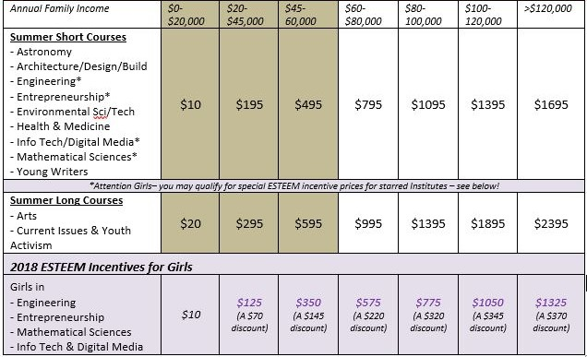
Your signature below certifies that the financial information you have provided is accurate and that you understand, acknowledge, and agree with the following disclosures and requirements.
Governor’s Institutes of Vermont will hold my information confidential. You have my consent to use it to administer the Financial Aid Program, including aggregate reports and publications that include non-identifying information.
It is my responsibility to mail this application in time to meet the deadline of April 1, 2018. I understand that if it is received after this date, it may disqualify me to receive financial aid. I understand financial assistance is awarded on a first-ask, first-serve basis.
I understand that once notified of acceptance, it is my responsibility to confirm my child’s attendance promptly and that not doing so may result in losing financial aid.
I acknowledge that every family must contribute some portion towards tuition (either from personal funds or from their own fundraising) and I will pay the required balance if my child is accepted and enrolled.
Parent/Guardian Signature: _______________________________ Date: ______________
PRINT Parent/Guardian Name: ____________________________
Please confirm the email address and phone number at which GIV staff can best communicate with you:
Email Address: ______________________________________________________________
Phone Number: ______________________________________________________________
Thanks for applying!

