Step 1 – Print and complete an application.
Complete your application, then have your parent or guardian complete the parent portion of the application and sign it. (Incomplete applications can delay the process.)

20 West Canal St., Suite C5
Winooski, VT 05404
802-865-4448 / www.giv.org
Summer Institute Application 2020
Step 3 – Submit your completed application with your $25 application fee to your school.
Be sure to submit your application to your school before their deadline. Each school sets its own deadline, so check with your school contact or the person listed on the GIV posters in your school.
All applications must include a check for the $25 application fee made out to Governor’s Institute unless you are applying for reduced tuition of $295 or less and we receive your completed financial worksheet at the same time as your completed application. The application fee is non-refundable.

Don’t Let Money Concerns Stop You From Applying!
Reduced Tuition Is Available.

Admission decisions are made without taking into account a family’s
ability to pay. We encourage all families who need financial assistance
to apply for reduced tuition. Print the Financial Worksheet from http://www.giv.org/finaid. Please be sure to include a copy of the first
page only of your family’s most recent tax returns with your application.
If parents are filing separately, we need documentation from each
parent. We cannot fund reduced tuition applications with fields
left blank or without tax information.
Step 2 – Ask two adults to fill out recommendation forms.
You can ask teachers, mentors, or other adults who know you well (but no relatives!). Choose the adults you feel can speak best to your interests and abilities. They can use the forms in this packet or simply write their own letter of recommendation. Recommendations are due with your application.

Governor’s Institutes
Application Checklist

Before your school’s application deadline, you need to submit to your school contact:
- Application (be sure to include your 2nd choice Institute if you are willing to accept it if your first choice is full.)

- A parent or guardian’s signature and date on page 3

- Two recommendations

- $25 non-refundable application fee (unless requesting a tuition amount of $250 or less)

If you are applying for reduced tuition, you can submit the following directly to GIV:
- Financial aid worksheet
(with a copy of both parents’ most recent tax return- first page only.)

Once you’ve applied, be sure to check your email often. Much of GIV’s communication with you will be via email.
Email apply@giv.org if you have questions.

Thank you for your interest in applying to the Governor’s Institutes of Vermont. Here is your application and guide to the application process. Please email us at apply@giv.org if you have any questions.
GIV APPLICATION COVER PAGE - Return this form to your school contact with your $25 application fee (unless requesting a tuition amount of $250 or less).

I would like to participate in a Governor’s Institutes summer program. My first and second choices are: (please fill out a 2nd choice only if you are willing to accept this choice!)

First Choice
Second Choice
Second Institute

Have you ever attended a Governor’s Institute? ___ No ___Yes Which/When: ___________
Date of Birth: ______________ Age: ______ Male / Female / Trans/Non-Binary
Legal First Name: ____________________ MI _____ Last Name: _______________________
Preferred First Name: ___________________ T-shirt size (adult XS-XXXL) _______
Home Phone: ___________________ Your Cell Phone: ___________________________
Your Email: _______________________________
Address: ______________________________________ City: ___________________ St: ____ Zip: ______
Your School: _______________________ Current Grade: _________ Graduation Year: _____
Will you be applying for reduced tuition? ____Yes ____ No (see chart on next page for tuition details)
VSAC Outreach Student: ____Yes ____ No
If English is not your parent/guardian(s) first language, can you act as an interpreter or do you need GIV enrollment forms to be translated into another language? _____Yes _____No
If you or your parents/guardians require translation before you can finish the application, please call or email GIV: 802 865-4448.
Parent/Guardian #1 Information Relationship to student: ________________________
Name: _________________________ Phone (home): _____________________________ Address: _______________________ City: ________________ St: _____ Zip: _________ Employer: ______________________________ Phone (work): ___________________
Email: ___________________________________ Cell________________________
Parent/Guardian #2 Information Relationship to student: __________________________
Name: _______________________________ Phone (home): _________________________ Address: _______________________ City: ________________ St: _____ Zip: __________ Employer: ______________________________ Phone (work): ___________________
Email: ___________________________________ Cell________________________
What made you decide to apply to GIV? Alum/Friend (name?) ____________________Radio ad (station?) ________________ Teacher (name?) _______________________ School (where?) __________________
Website (which one?) ____________________Other (be specific) _________________
Sliding Scale Tuition

GIV offers a sliding scale tuition structure to make sure young Vermonters from all backgrounds can participate. Full tuition is $1685 for most Institutes, or $1985 for the longer ones, but we will provide tuition assistance for families unable to pay the full amount.

The below chart shows recommended summer tuition levels based on family incomes. Please select the highest tuition level that your family can comfortably afford.

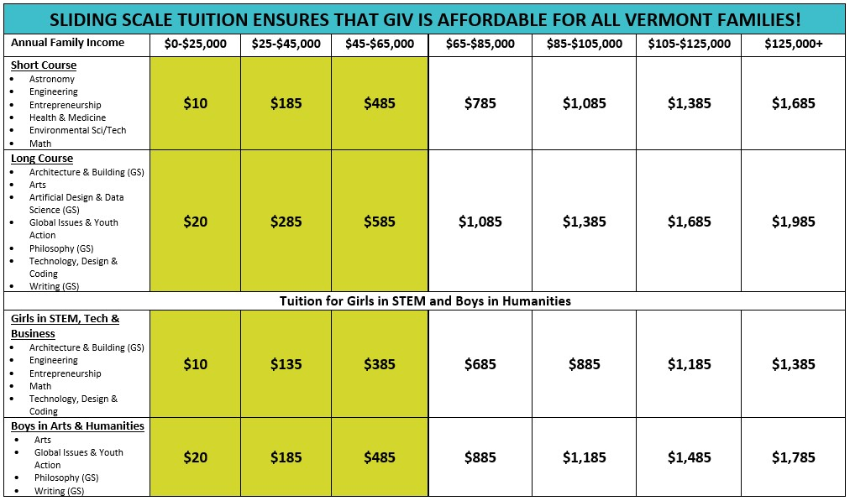
All tuition levels are suggested, and extenuating circumstances are taken into account. For more information, visit www.giv.org/tuition or call us at (802)865-4448.

To qualify for a rate in the green shaded columns, you must provide a financial aid worksheet and income tax documentation. If your income does not qualify you for lowered tuition but you have extenuating circumstances, submit the completed financial aid worksheet and tax documentation plus a note describing those circumstances.

If tuition is being covered by a third party such as an agency or school, the third party does not qualify for sliding scale tuition discounts. The third-party rate is $1685 (short course) or $1985 (long course).

Helpful Hints:
- For a split household, please combine both family incomes. We’ll be looking for financial documentation from both parents if you are applying for a tuition amount in the shaded columns.
- Extenuating circumstances can include anything that affects your family’s ability to pay, such as job loss, family size, elder parent care, hurricane damage, siblings in college, illness or injury, etc. Please send us a note describing the situation so that we are best able to help.
- Some schools and foster care agencies pay for tuition, as does Vocational Rehab.
- We’ll be happy to send you a donation receipt for any amount you choose to pay over your recommended tuition. Just give us a heads up that you’re doing so!
- Installment-based payment plans are available by calling 865-4448.

GIV Summer Tuition Selection and Financial Agreement
A parent or guardian must complete this portion of the application and sign in the spaces provided below.

I hereby submit an application for my student, _______________________________, to attend the Governor’s Institutes of Vermont this summer. Enclosed is a $25 application fee (unless enclosing a financial aid application for reduced tuition of $250 or less). I understand that this will NOT be refunded if my student is not enrolled.

Preferred Tuition Amount: $_________________________ (See chart on previous page)

___ I would like to make a tax-deductible charitable contribution to help another student attend. Please add $______________ to my invoice.
___ I am sending in an application for reduced tuition: ____ Yes ____ No
(A reduced tuition application is required for any amount that falls in the shaded columns on the tuition chart on the previous page. Find the reduced tuition application at http://www.giv.org/finaid).
___ Please contact me about a payment plan: ____ Yes ____ No

If accepted by the Governor’s Institutes, I agree to pay a non-refundable deposit by May 1 and the full balance of student tuition I owe by June 1 in order to secure my student’s enrollment.

Parent or Guardian Signature: ____________________________ Date: ___________
PRINT Parent or Guardian Name__________________________________________

Student Questionnaire - These are part of what we use to make admissions decisions. Aim for 3-6 sentences. Use extra sheets for your response if desired. Please print legibly.
- What are your favorite subjects in high school and why? What have been your most positive learning experiences? What made them so constructive?

- If you could be an expert in something, what would it be?

- What do you most like to do outside of school?

- Describe an activity you have participated in or initiated that has had a positive impact on your school, class or community.

- Why is attending a Governor’s Institute important to you? What do you hope to gain from the experience? Do you have a specific focus in mind for your experience at the Institute?

- What are some of your goals about your future education and career?

- How will you share the benefit of your GIV experience with your peers and community after you return home?

- For Math applicants only: Please include a list of high school math courses you have taken, the grades you received, and the name of your most recent math teacher. On a scale of 1-5 (5 being the highest) what is your level of computer competency?
RECOMMENDATION FORM
Teachers, counselors or principals: Please return this form or a personal letter to the applicant so she/he may submit it with their application. YOU MAY SUBSTITUTE A PERSONAL LETTER FOR ALL APPLICANTS; WE REQUIRE A LETTER FOR MATH APPLICANTS.
I hereby recommend this student to be accepted into the prestigious GIV accelerated learning program listed below.
Student’s Name: (Please print) _________________________________________________
Institute 1st choice: _________________________________________________________
- Please check one or more that best describe the student’s MOTIVATION:
- Highly self-motivated and engaged in learning
- Consistently shows excitement about ideas for learning activities
- Has good energy and ideas
- Works hardest when directed
- Show occasional but brief interest in learning new things

- Please check one or more of the following that best describe the student’s ABILITY:
- Exhibits superior skills and ideas in one or more areas
- Has good ideas and strong skills for implementing them
- Ideas and skills meet and sometimes exceed average
- Strength of ideas outweighs this student’s ability to communicate them
- Strength of skills outweigh this student’s ideation

- Please check one or more that best describe the student’s READINESS:
- Socially adept; a leader in his or her peer group
- Fits in well in all or most group and academic settings
- May be inexperienced or anxious, but compensates well
- Requires significant support in executive function or social interaction

- What do you think this student will gain by attending a Governor’s Institute?

- Please comment on the student’s interest in the subject matter at this Institute.

- Will this student be applying for financial aid? ___ Yes ___ No ___ I don’t know
(Note: GIV admissions are need-blind. Your answer here helps us help students with financial needs by cueing us to ask for a financial aid application if it’s missing.)
A signed letter must be attached for Math Institute applicants.
Recommended by ___________________________________ Date___________________
Relationship to applicant ______________________________ School____________________
(Note: If your nomination is the first step in the student’s application process and you feel he/she is a good fit, please help him/her have the confidence to apply! If you are aware of any reason a particular student may not be a good match for a Governor’s Institute, please contact us confidentially at 865-4448.)
RECOMMENDATION FORM
Teachers, counselors or principals: Please return this form or a personal letter to the applicant so she/he may submit it with their application. YOU MAY SUBSTITUTE A PERSONAL LETTER FOR ALL APPLICANTS; WE REQUIRE A LETTER FOR MATH APPLICANTS.
I hereby recommend this student to be accepted into the prestigious GIV accelerated learning program listed below.
Student’s Name: (Please print) _________________________________________________
Institute 1st choice: _________________________________________________________
- Please check one or more that best describe the student’s MOTIVATION:
- Highly self-motivated and engaged in learning
- Consistently shows excitement about ideas for learning activities
- Has good energy and ideas
- Works hardest when directed
- Show occasional but brief interest in learning new things

- Please check one or more of the following that best describe the student’s ABILITY:
- Exhibits superior skills and ideas in one or more areas
- Has good ideas and strong skills for implementing them
- Ideas and skills meet and sometimes exceed average
- Strength of ideas outweighs this student’s ability to communicate them
- Strength of skills outweigh this student’s ideation

- Please check one or more that best describe the student’s READINESS:
- Socially adept; a leader in his or her peer group
- Fits in well in all or most group and academic settings
- May be inexperienced or anxious, but compensates well
- Requires significant support in executive function or social interaction

- What do you think this student will gain by attending a Governor’s Institute?

- Please comment on the student’s interest in the subject matter at this Institute.

- Will this student be applying for financial aid? ___ Yes ___ No ___ I don’t know
(Note: GIV admissions are need-blind. Your answer here helps us help students with financial needs by cueing us to ask for a financial aid application if it’s missing.)
A signed letter must be attached for Math Institute applicants.
Recommended by ___________________________________ Date___________________
Relationship to applicant ______________________________ School____________________
(Note: If your nomination is the first step in the student’s application process and you feel he/she is a good fit, please help him/her have the confidence to apply! If you are aware of any reason a particular student may not be a good match for a Governor’s Institute, please contact us confidentially at 865-4448.)

